A Project Synopsis

On

# IOT BASED SENSOR VIRTUALIZATION AND ANALYTICS USING DEEP LEARNING

Submitted in partial fulfillment of the requirement of

University of Mumbai for the Degree of

**Bachelor of Technology**

In

**Electronics and Telecommunication Engineering**

Submitted By

**Divya Mokal**

**SatyaMurthy Musti**

**Nikita Patil**

**Gayatri Shinde**

Supervisor

**Ruchira Patole**



**Department of Electronics and Telecommunication Engineering**

**PILLAI COLLEGE OF ENGINEERING**

**New Panvel – 410 206**

**UNIVERSITY OF MUMBAI**

**Academic Year 2022 – 23**



## DEPARTMENT OF ELECTRONICS AND TELECOMMUNICATION ENGINEERING

Pillai College of Engineering

New Panvel – 410 206

CERTIFICATE

This is to certify that the requirements for the B.Tech Synopsis entitled ‘**Iot based Sensor Virtualisation and Analytics using Deep Learning**’ have been successfully completed by the following students:

**Name Roll No.**

Divya Mokal B01

SatyaMurthy Musti B03

Nikita Patil B15

Gayatri Shinde B38

In partial fulfillment of Bachelor of Technology of Mumbai University in the Department of Electronics and Telecommunication Engineering, Pillai College of Engineering, New Panvel – 410 206 during the Academic Year 2022 – 2023.

**_____________________**

**Supervisor**

**(Ruchira Patole)**

**_____________________ _____________________**

**Head of Department Principal**

**Dr. Avinash R. Vaidya Dr. Sandeep M. Joshi**

**_____________________ _____________________**

**Internal Examiner External Examiner**

i



**PILLAI COLLEGE OF ENGINEERING**

**NEW PANVEL – 410 206**

**DEPARTMENT OF ELECTRONICS AND TELECOMMUNICATION ENGINEERING**

SYNOPSIS APPROVAL FOR B.Tech

This project synopsis is entitled “**Iot based Sensor Virtualisation and Analytics using Deep Learning**” by **Divya Mokal, Satyamurthy. M, Nikita Patil, Gayatri Shinde** are approved for the degree of B.Tech in ELECTRONICS AND TELECOMMUNICATION ENGINEERING.

Examiners:

1. ________________

2. ________________

Supervisors:

1. ________________

2. ________________

Chairman:

1. ________________

Date: 16/04/23

Place: Panvel

ii**Declaration**

We declare that this written submission for B.Tech. Declaration entitled “**Iot based Sensor Virtualisation and Analytics using Deep Learning**” represents our ideas in our own words and where others' ideas or words have been included. We have adequately cited and referenced the original sources. We also declared that we have adhered to all principles of academic honesty and integrity and have not misrepresented or fabricated or falsified any ideas / data / fact / source in our submission. We understand that any violation of the above will cause disciplinary action by the institute and also evoke penal action from the sources which have thus not been properly cited or from whom paper permission has not been taken when needed.

**Project Group Members:**

**Divya Mokal** _______________________

**Satyamurthy. M**_____________________

**Nikita Patil**__________________________

**Gayatri Shinde** _____________________

Date: 16/04/23

Place: Panvel

iii

**Table of Contents**

| Abstract................................................................................................................................ | | | | i |
| --- | --- | --- | --- | --- |
| List of Figures...................................................................................................................... | | | | ii |
| List of Tables....................................................................................................................... | | | | iii |
| **1.** | Introduction................................................................................................................. | | | 1 |
|  | **1.1** | Fundamentals................................................................................................... | | 1 |
|  | **1.2** | Objectives........................................................................................................ | | 1 |
|  | **1.3** | Scope............................................................................................................... | | 2 |
|  | **1.4** | Outline……………………………….............................................................. | | 2 |
| **2.** | Literature Survey......................................................................................................... | | | 3 |
|  | **2.1** | Introduction……. ……………………............................................................ | | 3 |
|  | **2.2** | Literature Review ………………………………………................................ | | 4 |
|  | **2.3** | Summary of Literature Survey.…………………………................................ | | 4 |
| **3.** | Theory ......................................................................................................................... | | | 5 |
|  | **3.1** | Overview…………………….......................................................................... | | 6 |
|  |  | 3.1.1 | Existing System Architecture………………………………………. | 8 |
|  |  | 3.1.2 | Proposed System Architecture……………………………………… | 9 |
|  | **3.2** | Requirements for Implementation ………...................................................... | | 10 |
|  |  | 3.2.1 | Algorithms / Techniques….................................................................. | 10 |
|  |  | 3.2.2 | Use Case Diagram / Activity Diagram…........................................... | 10 |
|  |  |  |  |  |
|  |  | 3.2.3 | Hardware and Software Specifications…........................................... | 10 |
|  |  |  | |  |
| **4.** | Applications……………………................................................................................. | | | 13 |
|  |  |  | |  |
|  |  |  | |  |
| **5.** | Summary….................................................................................................................. | | | 15 |
| References............................................................................................................................ | | | | 16 |
| Acknowledgement……………………………………………………………………......... | | | | 17 |

## **Abstract**

Internet of Things (IoT) and Network Softwarization are fast becoming core technologies of information systems and network management for the next generation Internet. The concept of IoT means more than just devices connecting to the global Internet. IoT is closely coupled with sensor technology, because in most of the cases sensors & actuators are part of a larger IoT network. These IoT sensors & actuators may produce large volumes of data. Hence, the need for installing new network access & core devices will increase. To manage the network devices efficiently, the network hardware resources need to be virtualized.

Virtualization is the logical abstraction of the underlying hardware devices within a network, through software implementation. Here we use deep learning, a computer model which performs classification tasks directly from images, text, or sound. Virtual sensor is a pure software sensor which autonomously produces signals by combining and aggregating signals that it receives (synchronously or asynchronously) from physical or other virtual sensors. Virtual sensors serve to overcome a number of weaknesses of purely physical sensors.

vi

**List of Figures**

| Figure 1.1 | Virtualisation |  |
| --- | --- | --- |
| Figure 3.1.1 | SVM architecture |  |
| Figure 3.2.2 | Block diagram for Virtualization |  |
|  |  |  |
|  |  |  |

vii

**List of Tables**

| Table 3.1 | Sample Dataset Used for Experiment |  |
| --- | --- | --- |
| Table 3.2 | Hardware details |  |
| Table 3.3 | Software details |  |
|  |  |  |
|  |  |  |

viii

**Chapter 1**

**Introduction**

**1.1 Fundamentals**

Virtualization is a process of creating a virtual or actual version of something. The technique which can create a virtual version of IT datacenter components such as Compute, storage and network etc. Hypervisor is one of the commonly used virtualization technology to create virtualized IT infrastructures

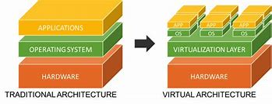

Fig 1.1: Virtualisation

The Figure 1.1 shows the basic idea of how virtualisation takes place. Generally, sensors are used in the architecture of IOT devices. Sensors are used for sensing things and devices etc. A device that provides a usable output in response to a specified measurement. The sensor attains a physical parameter and converts it into a signal suitable for processing (e.g. electrical, mechanical, optical) the characteristics of any device or material to detect the presence of a particular physical quantity. The output of the sensor is a signal which is converted to a human-readable form like changes in characteristics, changes in resistance, capacitance, impedance etc.

**1.2 Objectives**

The objective of our project are as follows:

* To design a smart IoT application service gateway and virtualization.
* To develop and build a prototype of the system based on the Raspberry Pi.
* To study and describe how the Raspberry Pi can be interfaced with sensors using the concept of virtualization.
* To elaborate on a conceptual framework of a virtual sensor and its inherent assumptions.
* To represent a software layer that provides indirect measurements of a process under variable/abstract condition based on data gathered by physical/virtual sensors.
* To develop a system that can calculate the distance of the objects.
* To study and predict the position of the obstacles with the help of Sensor Virtualization and Deep Learning

**1.3 Scope**

The Internet of things (IoT) is an ecosystem of associated physical gadgets/objects that are available through the web. IoT is an arrangement of interrelated gadgets, advanced items, articles, individuals or creatures that are given novel identifiers (UIDs) and the capacity to move information over an organization without requiring any human collaboration.

Electronics HW and Embedded Software assume an essential part in IoT. Our project aims at creating a virtual system that is capable of sensing the obstacles using Ultrasonic sensors along with use of IoT based hardware device such as Raspberry Pi Pico . Also, the knowledge of Deep Learning is used for making predictions of the position of the object.

**1.4 Outline**

Internet of Things (IoT) and Network Softwarization are fast becoming core technologies of information systems for the next generation. The concept of IoT means more than just devices connecting to the global Internet. To manage the network devices efficiently, the network hardware resources need to be virtualized. Software-based virtual sensors offer an additional abstraction layer built on digital representations of sensor hardware. A physical sensor is a sensor that reacts to a physical stimulus (e.g. temperature, light, pressure, magnetism, or a particular motion). It transmits a resulting impulse – typically through electrical signals that can be captured and stored in digital form. Our project is all about sensing the physical stimulus by making use of sensors and IOT hardware devices

**Chapter 2**

**Literature Survey**

| **Sr. No.** | **Title** | **Inference** |
| --- | --- | --- |
| I | Virtual Sensors (2021) | This paper presents the foundation for AI-based information systems that can be used for machine learning and generate analytics-based solutions. |
| II | IoT Virtualization: A Survey of Software Definition & Function Virtualization Techniques for Internet of Things (2019) | This paper depicts management, configuration and flow scheduling of new technologies which is possible due to iot as it involves as it involves Network softwarization in the form of Software Defined Networks (SDN) and Network Function Virtualization (NFV). |
| III | Sentio: Distributed Sensor Virtualization for Mobile Apps (2018) | This paper suggests that a distributed middleware can be designed to provide mobile apps with seamless connectivity to remote sensors when the sensing code and the sensors are not physically on the same device |
| IV | Using Deep Learning for Object Distance Prediction in Digital Holography (2021) | This paper suggests that Deep Learning can be used to determine the distance of a view captured by a holographic camera for given the scale of the available dataset |

**Chapter 3**

**Proposed System**

# 3.1 Overview

The system overview is presented in this Section. Network virtualization is the mechanism of combining both software & hardware resources and network functionality into a logically configured single software-based administrative entity. The term virtual network refers to the resulting software network entity. In other words, a successful network virtualization would require platform virtualization along with resource virtualization.

This is achieved through the Virtualization Layer, which is an additional abstraction layer between network and storage hardware, and the applications running on it. It can be categorized as either an external virtualization, consisting of many networks into a virtual unit, or internal virtualization serving network-like functionality to software containers on a single network server.

# 3.1.1 Existing System Architecture

*SVM* simplifies application development by providing an abstraction of the IoT devices that are present in the local field. *SVM* makes it look as if the external devices are on-board sensor components such as accelerometer, gyro, GPS, or camera. When applications interconnect with the *SVM* layer, a set of open APIs are provided to the applications for them to interact with the *SVM* layer and to easily access these resources. For example,launchSensorDiscovery() API searches for all the external physical sensors that can be connected to the smart device via any of the network access interfaces (e.g., Bluetooth, WiFi, and ZigBee) on the smart device and provides a list of those sensors.

Although this process allows easy access to external IoT devices via mobile platforms from various applications, the increase in the number of interacting applications can result in conflicts among resource requests. Since such application level algorithms are not enforced by any standardization body, we cannot assure that these conflicts will be properly processed at the end-device level. As a result,besides managing the connectivity, another major role of the SVM engine is to resolve such conflicts caused by multiple requests from different applications.

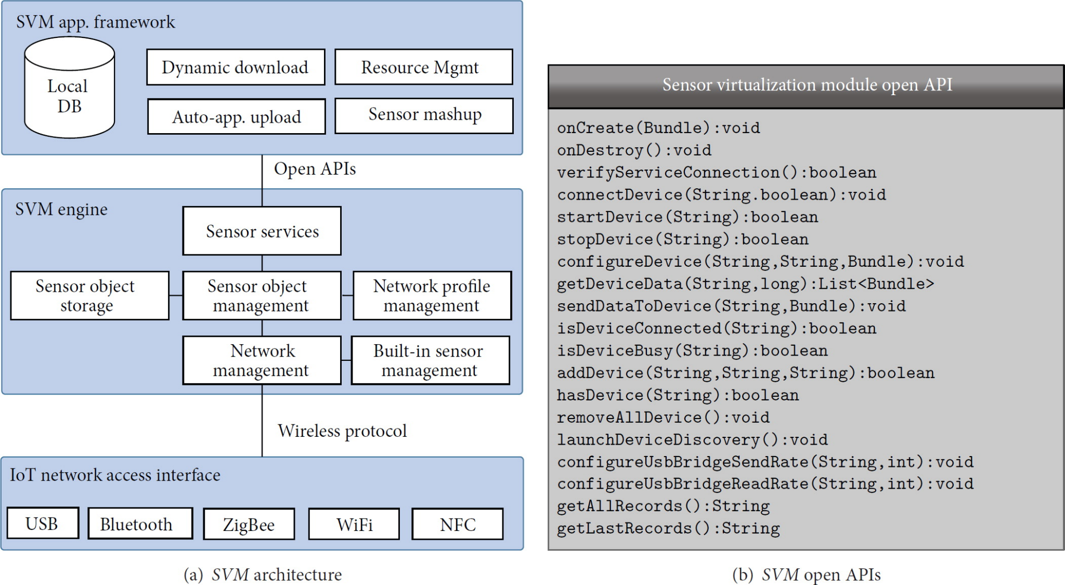

Fig 3.1: SVM architecture

# 3.1.2 Proposed System Architecture

The previous sections discussed the strengths and weaknesses of the existing system. In order to achieve better domain results, we design

In this system we are using two raspberry pi 4 with five sensors of single type and connecting them in wireless mode . By this system architecture we will be able to perform virtualization wirelessly . So that we can check the system whenever and wherever we want .

Virtual sensors will provide indirect measurements of data by combining data from different heterogeneous physical sensors in order to provide services to the user . The sensor virtualization technique will allow the user to obtain preferred and precise information in a more efficient manner from a limited number of sensors. Furthermore, this helps in reducing the energy consumption and cost of the overall network.

**3.2 Implementation Details**

The implementation detail is given in this section.

**3.2.1 Technique ABC**

Virtualization is the creation of a virtual version rather than an actual version of something, such as an operating system (OS), a server, a storage device or network resources.

For example, here we create a system which uses one raspberry pi 4 with five smoke sensors

which detect LPG gas connected to each other. So we connect the network with another raspberry pi 4 in wireless mode.By this, the outcome of this network will be shown as the same as that which we have checked by actually working with the sensors. So this will show that we have created a virtual version of a physical network which gives the same result as the physical version.

**3.2.2 Use Case Diagram / Activity Diagram**

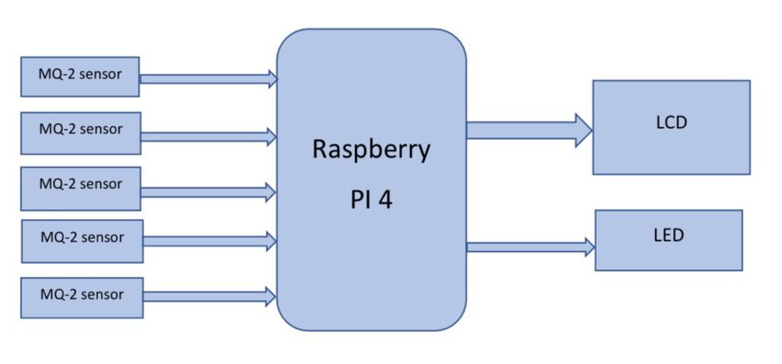

Fig 3.2 : Block diagram for Virtualization

The above diagram shows :

1] Five MQ-2 gas sensors are connected to raspberry pi 4 which can detect LPG gas . The MQ2 gas sensor operates on 5V DC and consumes approximately 800mW. It can detect LPG, Smoke, Alcohol, Propane, Hydrogen, Methane and Carbon Monoxide concentrations ranging from 200 to 10000 ppm.

2] One LCD connected to raspberry pi 4 which will display the result. It is a 16x4 which means it will take upto 16 characters and 4 rows.

3] And one LED which glows when detected by sensor 5.

**3.2.3 Hardware and Software Specifications**

The experiment setup is carried out on a computer system which has the different hardware and software specifications as given in Table 3.2 and Table 3.3 respectively.

Table 3.2 Hardware details (Raspberry Pi 4)

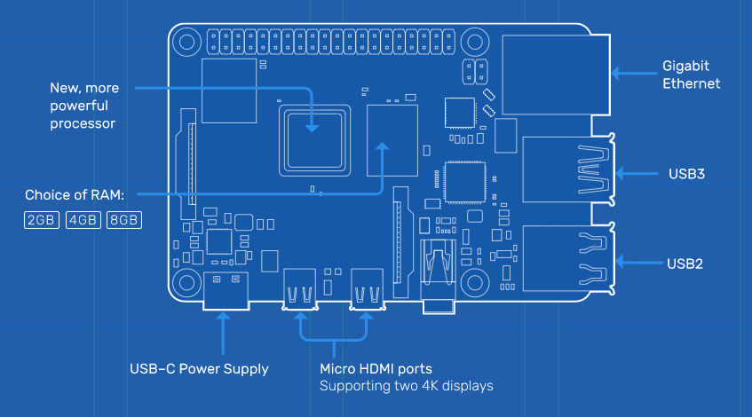

* Broadcom BCM2711, Quad core Cortex-A72 (ARM v8) 64-bit SoC @ 1.5GHz
* 1GB, 2GB, 4GB or 8GB LPDDR4-3200 SDRAM (depending on model)
* 2.4 GHz and 5.0 GHz IEEE 802.11ac wireless, Bluetooth 5.0, BLE
* Gigabit Ethernet
* 2 USB 3.0 ports; 2 USB 2.0 ports.
* Raspberry Pi standard 40 pin GPIO header (fully backwards compatible with previous boards)
* 2 × micro-HDMI ports (up to 4kp60 supported)
* 2-lane MIPI DSI display port
* 2-lane MIPI CSI camera port
* 4-pole stereo audio and composite video port
* H.265 (4kp60 decode), H264 (1080p60 decode, 1080p30 encode)
* OpenGL ES 3.1, Vulkan 1.0
* Micro-SD card slot for loading operating system and data storage
* 5V DC via USB-C connector (minimum 3A*)

Table 3.3 Hardware details (Raspberrypi pico)

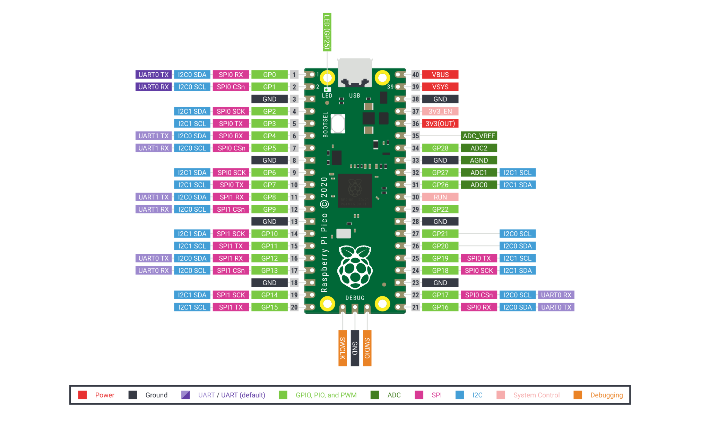

* RP2040 microcontroller with 2MB Flash
* Micro-USB B port for power and data (and for reprogramming the Flash)
* 40 pin 21×51 'DIP' style 1mm thick PCB with 0.1" through-hole pins also with edge castellations.
* 3-pin ARM Serial Wire Debug (SWD) port
* Simple yet highly flexible power supply architecture
* Dual-core cortex M0+ at up to 133MHz
* 264kB multi-bank high performance SRAM
* External Quad-SPI Flash with eXecute In Place (XIP) and 16kB on-chip cache
* High performance full-crossbar bus fabric

Table 3.4 Software details

| Software | Proteus, Thony |
| --- | --- |
| Programming Language | Python, Micropython |

**Chapter 4**

**Applications**

There are various applications of this domain system. The application is listed here.

**4.1 Robotics**

Deep Learning is heavily used for building [robots](https://www.simplilearn.com/future-of-robotics-article) to perform human-like tasks. Robots powered by Deep Learning use real-time updates to sense obstacles in their path and pre-plan their journey instantly. It can be used to carry goods in hospitals, factories, warehouses, inventory management, manufacturing products, etc.

**4.2 Visual Recognition**

In the lack of metadata, the only method to achieve this was through physical labor. The most you could do was order them by date, but downloaded photographs occasionally lack that metadata. Deep Learning, on the other hand, has made the job easier. Images may be sorted using it based on places recognised in pictures, faces, a mix of individuals, events, dates, and so on. To detect aspects when searching for a certain photo in a library, state-of-the-art visual recognition algorithms with various levels from basic to advanced are required.

**4.3 Resource Discovery**

In order to allocate resources for requests from different virtual sensor service providers, infrastructure providers must be able to determine the topology of the sensor networks they manage as well as the status of the corresponding sensor network elements. Moreover, adjacent infrastructure providers must also share reachability information to be able to establish links between their networks to enable inter domain sensor virtual network instantiation.

**4.4** . **Programmability**

To ensure flexibility, programmability of the virtual sensor network elements is an indispensable requirement. Only through programmability, virtualization can implement customized protocols and deploy diverse services. For sharing the resources of the resource constrained sensor node, programmability may provide an opportunity to do further research activities in VSNs.

**4.5 Quality of Service and Quality of Experience**

Quality of service and quality of experience are very important for all sorts of virtualizations. Quality of service is a measurement of network operating conditions such as noise or lost or dropped packets *etc.* Quality of Experience is a measurement used to determine how well that sensor network is satisfying the application level user requirements.

**4.6 Virtual Sensor Network Operations and Management**

in the underlying physical sensor network components can give rise to cascading failures in the virtual sensor networks directly hosted on those components. For instance, a physical link failure will result in failures of all the virtual links that pass through it. Similarly, any physical sensor node failure might require re-installations of the entire service provider’s custom software’s. Detection and effective isolation of such failures as well as prevention and recuperation from them to stable states are all open research challenges.

**Chapter 5**

**Summary**

In this report, study of sensor virtualization and analytics using deep learning IOT based gas detectors. IOT technology has come a long way since it was conceptualized two decades ago. It has become more efficient, more applicable to today’s applications and smarter. The work presented in this project was directed towards pushing IOT technology to the next level. The work has presented solutions to several problems and issues that have not been addressed in previous work. The principle of operation of Operation of IOT based gas leakage and monitoring system was shown by operating the Raspberry pi 4 model attached to an embedded system with required input and output gas level with the help of gas sensors. This results in a more efficient operation because it is connected to a LCD display. The choice of using a real time gas leakage monitoring and sensing the output levels of gas has been clearly observed by the help of this system.

**References**

[1] Dominic Martin, Niklas Kuhl, Gerhard Satzger: "Virtual Sensors"

[2] Iqbal Alam, Kashif Sharif, Member, IEEE, Fan Li, Member, IEEE"IoT Virtualization: A Survey of Software Definition & Function Virtualization Techniques for Internet of Things"

[3] Hillol Debnath, Narain Gehani, Xiaoning Ding, Reza Curtmola and Cristian Borcea "Sentio: Distributed Sensor Virtualization for Mobile Apps"

[4] JeongGil Ko, Byung-Bog Lee, Kyesun Lee, Sang Gi Hong, Naesoo Kim, Jeongyeup Paek "Sensor Virtualization Module: Virtualizing IoT Devices on Mobile Smartphones for Effective Sensor Data Management"

[5] Kumar Keshamoni and Sabbani Hemanth. "Smart Gas Level Monitoring, Booking & Gas Leakage Detector over IoT " International Advance Computing Conference IEEE, 2017.

[6] S. El Bouanani, M. A. E. Kiram, and O. Achbarou, “Introduction to the internet of things security: Standardization and research challenges,” in Proc. of Int. Conf. on Information Assurance and Security, December 2015, pp. 32–37

[7] Saleem, T. J., & Chishti, M. A. (2019). Deep Learning for Internet of Things Data Analytics. Procedia Computer Science, 163, 381–390. doi:10.1016/j.procs.2019.12.120

**Acknowledgement**

We would like to express our sincere gratitude to our guide **Prof. Ruchira Patole** who gave us this opportunity to make this project & also helped, & guided us through obstacles along the way. Her guidance & support has helped us a lot in working on this project.

We would like to express my special thanks to our H.O.D of the Electronics and Telecommunication Department, **Dr. Avinash Vaidya** for giving us this opportunity and motivating us to do innovative things that will be beneficial for our future.

We would also like to thank our Principal **Dr. Sandeep Joshi** for giving us this golden opportunity in this college, for motivating us to think bigger & also for helping us in various phases of our academics.

**Divya Mokal**

**Satyamurthy. M**

**Nikita Patil**

**Gayatri Shinde**